1. <div class = “container-fluid”></div>

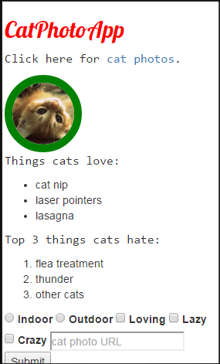 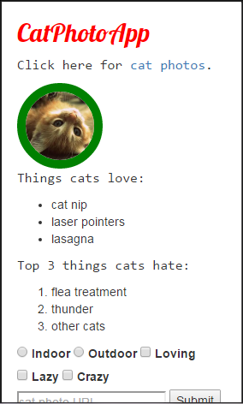

1. <img src =” <https://bit.ly/fcc-running-cats> “ class = “img-responsive”>

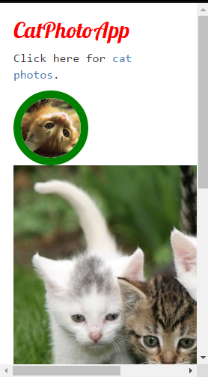 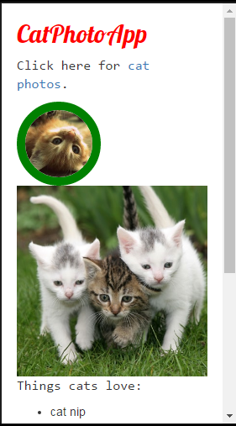

1. <h2 class = “text-center”>

 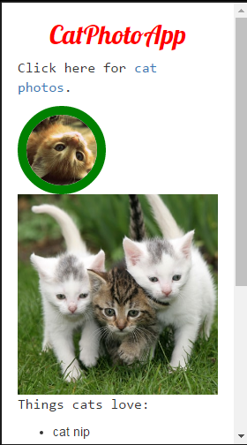

1. <button class = “btn”>Like</button>

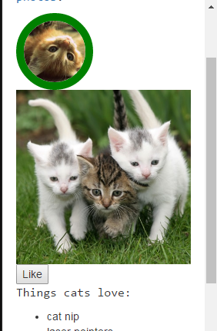 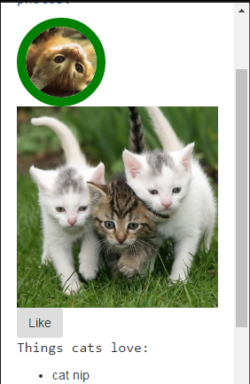

1. <button class=”btn btn-block”>

 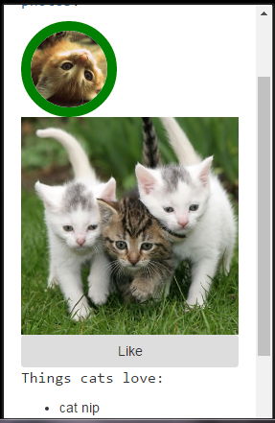

1. <button class =”btn btn-block btn-primary”>

 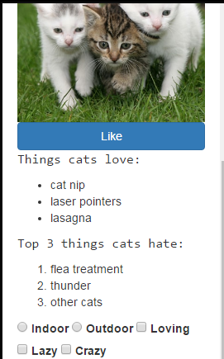

1. <button class="btn-info btn-block btn">Info<button>



1. <button class ="btn btn-block btn-danger">Delete</button>



1. <div class = "row">

<div class = "col-xs-4"><button class="btn btn-block btn-primary">Like</button></div>

<div class = "col-xs-4"><button class="btn btn-block btn-info">Info</button></div>

<div class = "col-xs-4"><button class="btn btn-block btn-danger">Delete</button></div>

</div>



1. <h2 class = “text-primary”> CatPhotoApp</h2>



1. <p>My name is <span class = “text-danger”>shivam</span></p>

Chnge the color of text to pink color just like text-primary.

1. <button class="btn btn-block btn-primary"><i class="fa fa-thumbs-up">Like</i></button>



1. <input type="text" placeholder="cat photo URL" class="form-control" required>



1. <div class="row">

<div class="col-xs-6">

<div class="well">

</div>

</div>

<div class="col-xs-6">

<div class="well">

</div>

</div>

</div>



1. <button class=”btn btn-default”></button>

